

HP Solution Test Bench

Installation and Administration Guide v 1.0

Table of Contents

Overview 4

Installation Notice 5

Server Setup 5

Verify Domain Controller Relationship 5

Firewall Settings 7

User Account Control Settings 8

New STB Server Installation 9

SQL Server is NOT Installed 10

Existing SQL Server Installation 15

Database Creation and Version Updates 18

Updating an Existing STB Server Installation 19

Troubleshooting a Failed Upgrade 20

Plugin Changes 22

Administrator Server Configuration Overview 23

Access STB Admin Control Panel 23

STB User Management 25

User Group Management 25

Adding New User Groups 25

Editing or Removing a User Group 26

Editing Membership of a User Group 27

Authorized User Management 28

Adding Authorized Users 28

Editing and Removing Authorized Users 29

Editing Group Scenario Access and Ownership 30

STB Device Management 31

Adding Print Devices 31

Editing and Removing Print Devices 32

Adding Print Servers 33

Edit or Review Print Servers 35

Remove Print Servers 36

Test Document Library 37

Add Test Documents to Library 37

Edit or Remove Documents in Document Library 39

Virtual Worker Pool 40

Adding Virtual Worker Pools 40

Edit or Remove a Virtual Worker Pool 41

Scheduling Cleanup of the Database 42

Troubleshooting Guide 43

Update Domain Controller Relationship 43

Elevating the Admin Privileges 45

Determine Print Server Device Allocation 48

Connecting to an Existing Database 50

# Overview

Solution Test Bench (STB) is a client-based server tool that allows testers to set up, run, and monitor automated testing of solutions running in conjunction with HP devices. STB is a client-based server tool that requires one instance of a server install and an SQL Express database.

The STB server supports one or more STB clients. The clients present a UI to the tester that allows the tester to set up, configure, and execute automated tests. Multiple clients and testers can use STB simultaneously.

The STB server includes support to manage and provide programmatic access to:

* test devices (i.e. MFPs, printers, or network scanner,)
* documents to be used in testing
* a pool of users’ credentials who serve as the actors in the execution of automated tests
* print servers and print queues that users can print to.

While not required for automated test, these features increase testing efficiency and reduce errors.

STB uses the Device Abstraction Toolkit (DAT), a SW library that allows the STB to interact transparently with a fleet of HP devices. The DAT handles the variations between different products and product families so that the tester does not need to have separate tests for different types of HP devices.

STB is designed to be used by both technicians and engineers. Engineers may decide test requirements and desired level of test coverage, while the setup, configuration, and execution of those test requirements through STB may be completed by technicians.

Users execute tests in STB through Test Scenarios. A Test Scenario allows the user to set up one or more virtual workers, who then execute a series of one or more workflows. The virtual worker can be configured using a number of variables, including, but not limited to:

* execute a set number of workflows (up to the 1000s)
* execute for a particular time duration (up to days or weeks)
* randomly execute a particular rate of workflows per time period.
* use one or several devices, including configuring several types of workers trying to use one device at the same time.

Test Scenarios and their test results are stored in the SQL database. This allows users to select and re-run previous tests, and recall test results at a later date. STB supports a variety of on demand reports.

The workflows that virtual workers can execute are determined by the set of STB Plug-Ins included in the STB package. The plug-in encodes the workflow actions and configuration options. Developers can enhance, modify, or write new plug-ins using the STB Plug-in SDK (provided separately. The STB Plug-in SDK may not be available at this time.)

In general, STB provides a setup of plug-ins for the native capabilities of the device, and for some standard office activities like printing, emailing, faxing, copying, and scanning (these may or may not be included in your STB package at this time.)

This document walks a user through the process of installing and using Solution Test Bench. The steps covered include:

* **Server setup** - Setting up a server prior to prepare for the STB install.
* **STB Server installation** - Installing the STB server, which includes installing an SQL Express database, if one doesn’t already exist.
* **STB Server configuration** - Configuring the STB server.
* **STB Client installation** - Installing one or more STB clients.
* **STB User Management** – Managing user access and permissions to STB.
* **STB Device Management** – Managing print servers and print devices used by STB Test Scenarios.
* **STB Test Document Library Management** – Managing documents used by STB Test Scenarios.
* **STB Database Maintenance** – Scheduling cleanup tasks for the STB database.

In addition, access the STB General User Guide for specific steps on configuring and executing Test Scenarios.

## Installation Notice

Please note that the Administrator will have access to the Solution Test Bench Control Panel that is used to configure the General user’s experience. These are two separate installations.

# Server Setup

Complete the following steps:

1. Open the STB installation file you received from HP.
2. Copy the STB Server installer file to your desktop for easy access.

## Verify Domain Controller Relationship

Before beginning the installation, complete the following steps:

1. Verify the domain relationship:
   1. Click **Start**.
   2. Type **Edit local users and groups** in the search field.   
      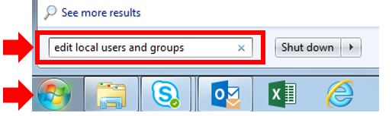
   3. Select **Edit local users and groups**.  
      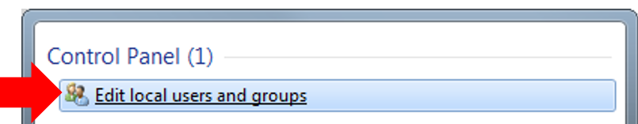
2. The Local Users and Groups screen opens.
3. Select **Groups** from the menu to display group Names.
4. Select **Administrators** from the Name list.  
   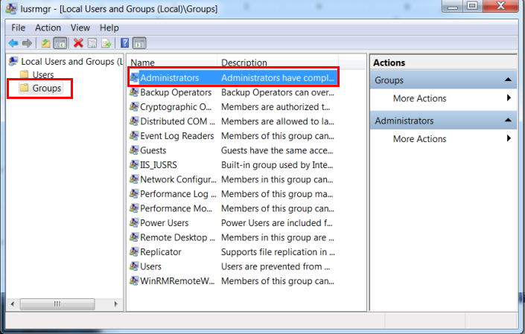
5. Review the **Administrators Properties** window as shown in Fig 1.4 below:
   1. If you see the proper domain name, proceed to the **Firewall Settings**.
   2. If the trust relationship has broken, refer to **Troubleshooting Guide – Domain Controller Relationship**.

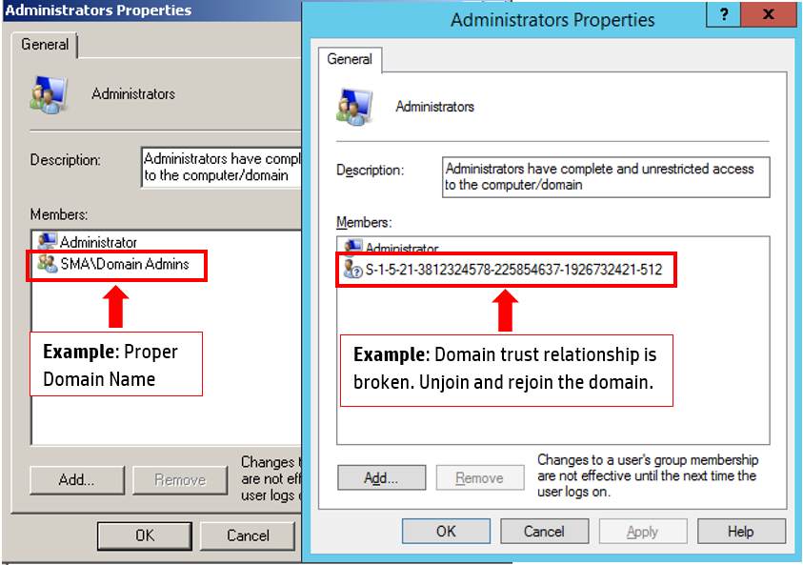

## Firewall Settings

To configure the firewall settings, complete the following steps:

1. Click the **Start** button.
2. Type **Firewall** in the search box.
3. Select **Windows Firewall****with Advanced Security** to open the **Windows Firewall with Advanced Security** pop-up.  
   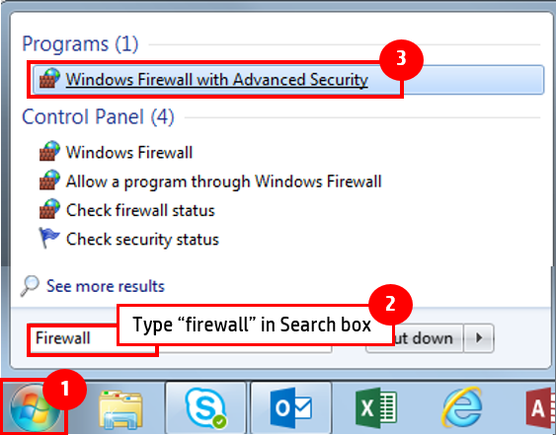
4. Click **Properties** to open the **Windows Firewall with Advanced Security** pop-up.
5. Change the **Firewall state** to “Off”for each profile: **Domain Profile**, **Private Profile**, and **Public Profile**.
6. Click **Apply**.
7. Click **OK**.   
   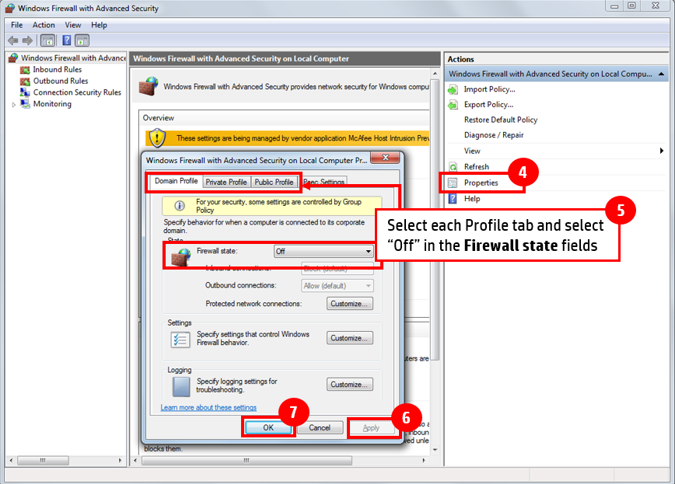
8. Windows firewall settings will appear as **off** for all three profiles.

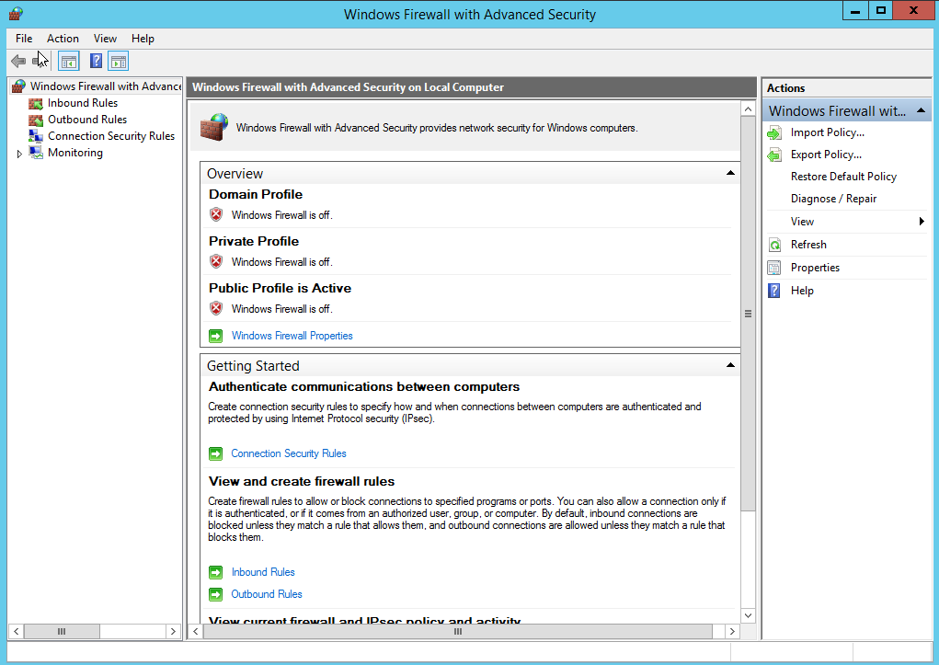

## User Account Control Settings

Set the account control settings by following the steps below:

1. Go to the **Start** button.
2. Type “UAC” in the search field.
3. Select **Change User Account Control settings** toopen **User Account Control Settings**.
4. Slide the bar to **Never notify**.
5. Click **OK**.  
   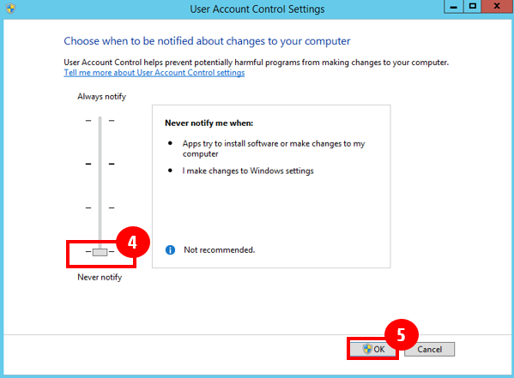

# New STB Server Installation

STB Server requires an instance of SQL Server running on the local machine. The STB Server Setup wizard will proceed based on ONE of the following conditions of the local machine:

* **SQL Server is NOT installed on the local machine**. In this case, STB Server Setup will download SQL Server Express 2014 and install it before proceeding with STB Server installation.
* **SQL Server is already installed on the local machine**. In this case, STB Server Setup will attempt to connect to the existing database. Note that the Setup wizard expects the database installation to be local (not remote). SQL Server 2014 or later is recommended and supported for STB operation.

If you already have a copy of the SQL Server Express installer file and you want to use it instead of downloading, you will need to run it manually on the server before running STB Server Setup.

Complete the following steps to install the STB server:

1. Right-click the STB Server installation file and select **Run as Administrator**:
   1. If the **Setup** pop-up warning stating that installer must be run with elevated administrator privileges displays, refer to Troubleshooting Guide – Elevating Admin Privileges.

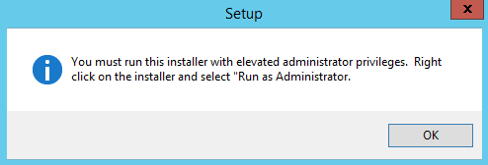

* 1. If the **Welcome to Solution Test Setup Wizard** displays, go to the next step.

1. Click **Next** on the Welcome and component installation screens.

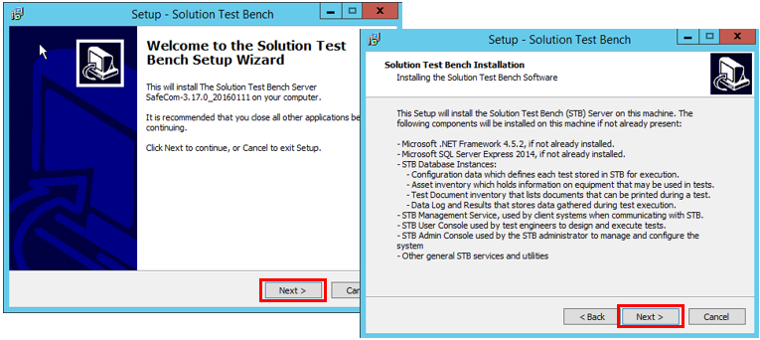

## SQL Server is NOT Installed

1. If an instance of SQL Server is not detected on the local machine, click Next to download and install SQL Server Express 2014.

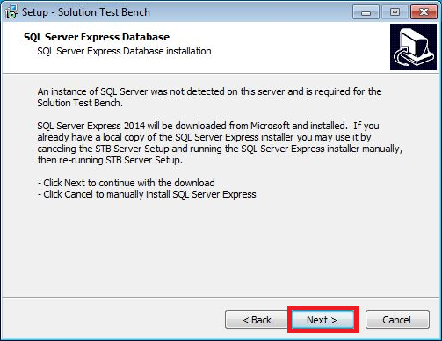

1. SQL Server Express 2014 is downloaded.

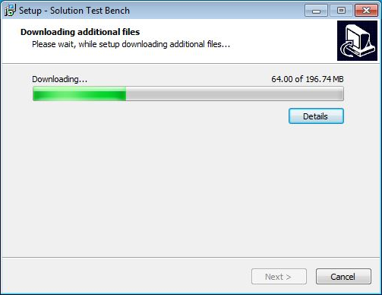

1. Click **Next** to use the default location for the following three screens:
   1. STB Destination Location
   2. STB File Share Location
   3. STB Database Files Location  
      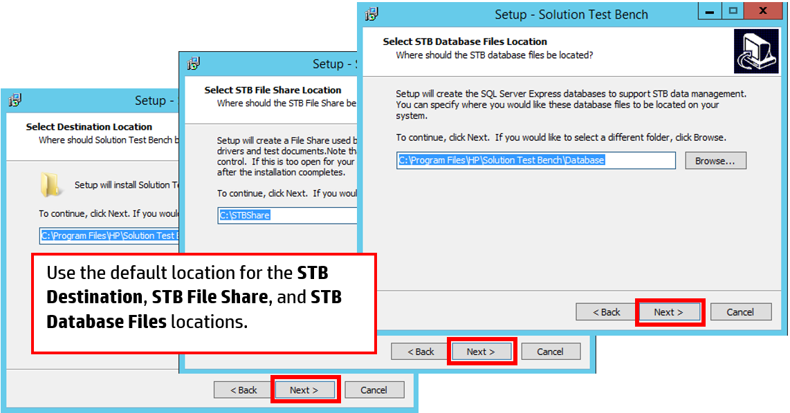
2. Enter an Organization name. Click **Next**.

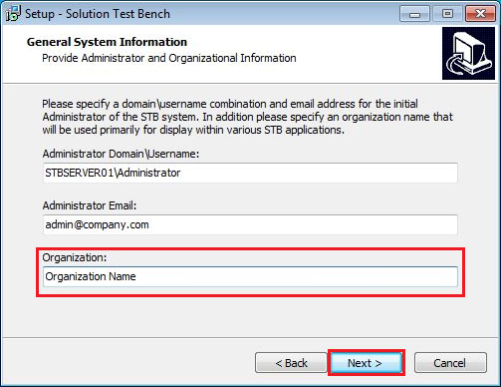

1. Click **Next** to create a shortcut in the Start Menu.

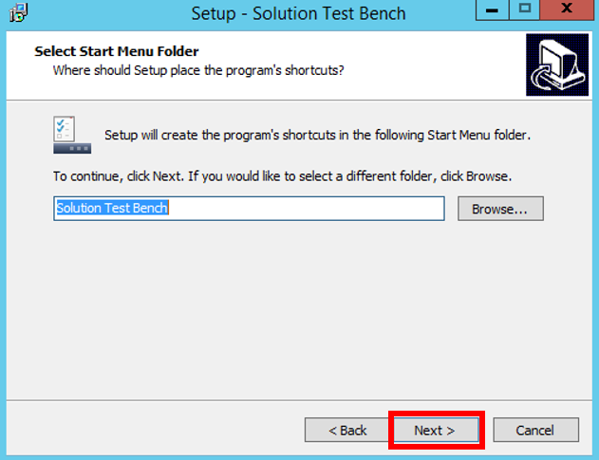

1. Click **Install**.

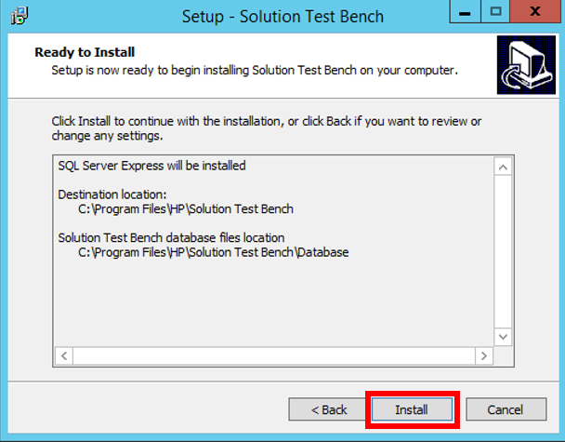

1. STB Server Setup will extract the installation files required for SQL Server Express 2014. When prompted, click **OK** to begin the SQL Server Express Setup wizard.

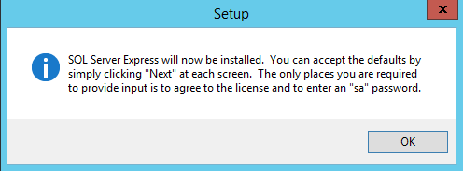

1. Select the **I accept the license terms** box.
2. Click **Next**.  
   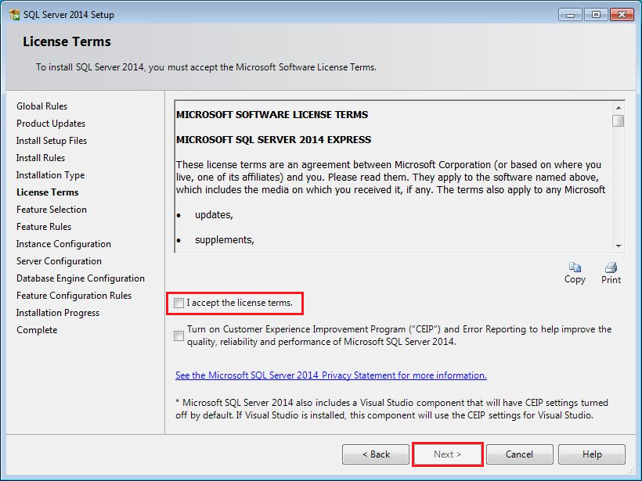
3. Click **Next** to use the default settings for the following four screens:
4. Microsoft Updates.
5. Feature Selections.
6. Instance Configuration
7. Server Configuration

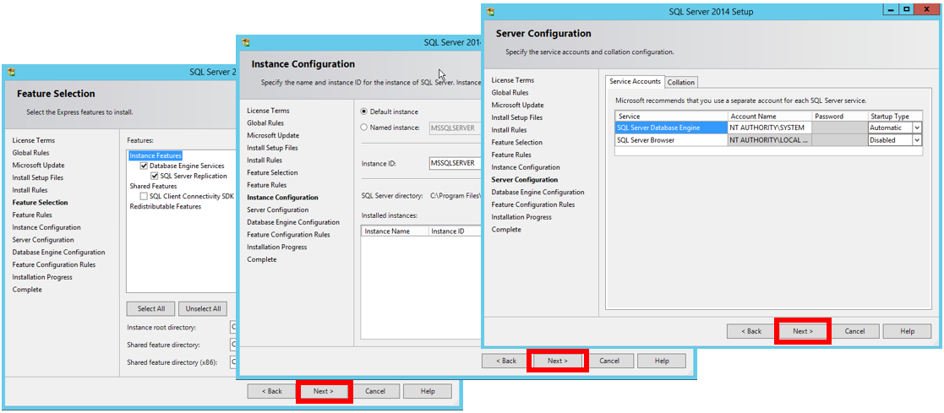

1. Type a valid SQL Admin password.
2. **Example:** The local administrator password is used.
3. Click **Next** to finalize the SQL installation.

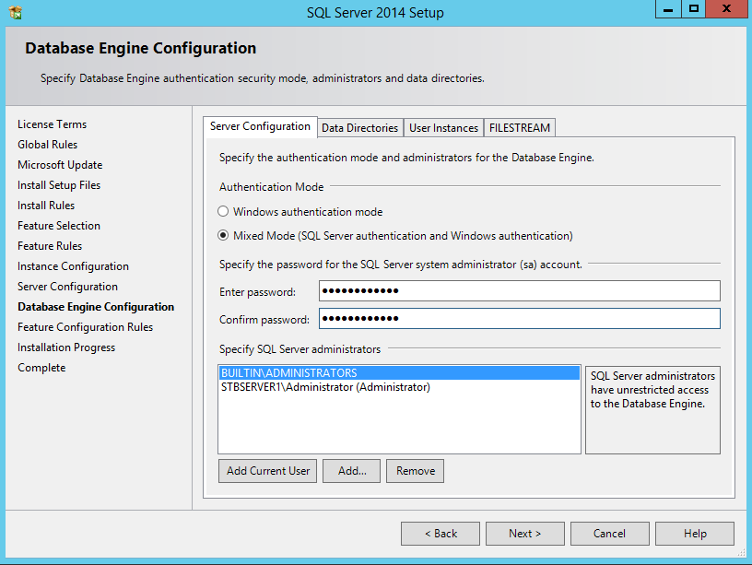

1. After the installation process completes, click **Close**.

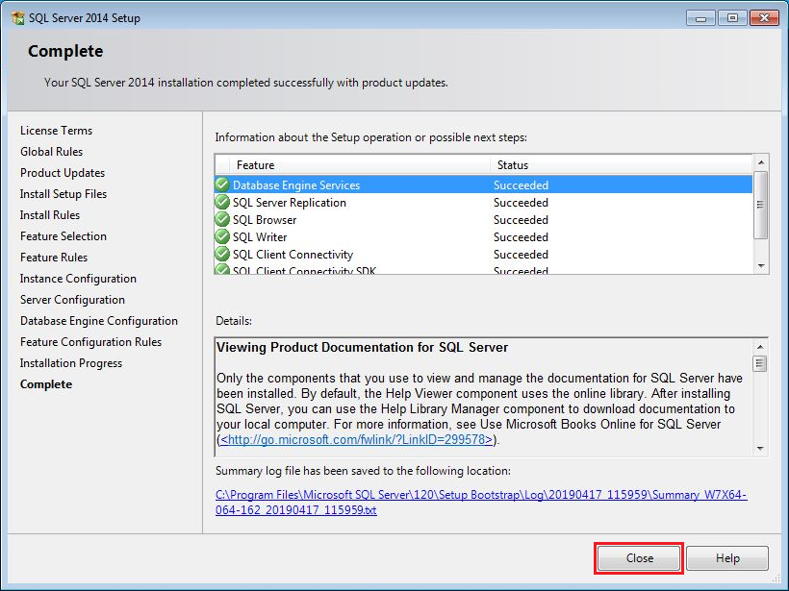

Skip to the section entitled Database Creation and Version Updates.

## Existing SQL Server Installation

1. Continuing from the Welcome screen, click **Next** to use the default location for the following two screens:
2. STB Destination Location
3. STB File Share Location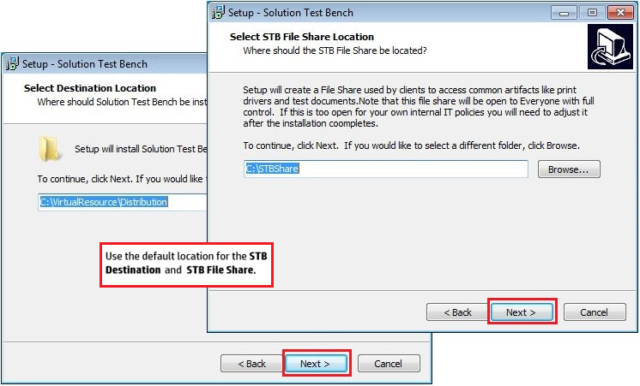
4. An existing instance of SQL Server is detected. Click **Next** to connect to the existing database using the credentials of the current logged-in user.

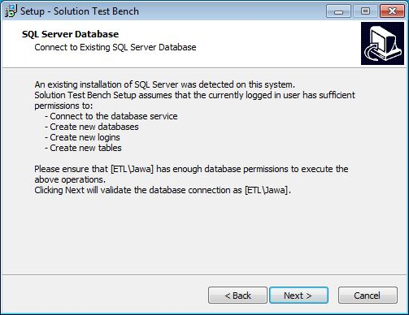

a. Click **OK** if the connection is successful.

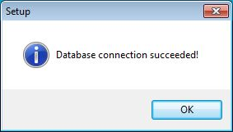

b. Click OK if the connection fails.

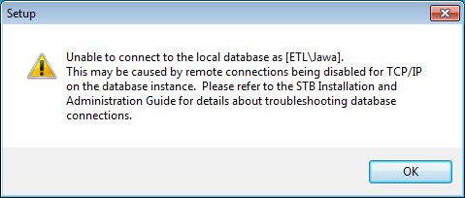

If this pop-up warning displays, refer to Troubleshooting Guide – Connecting to an Existing Database. STB Server Installer will not allow you to proceed until a successful connection to the database has been established.

1. Enter an Organization name. Click **Next**.



1. Click **Next** to create a shortcut in the Start Menu.



1. Click **Install**.

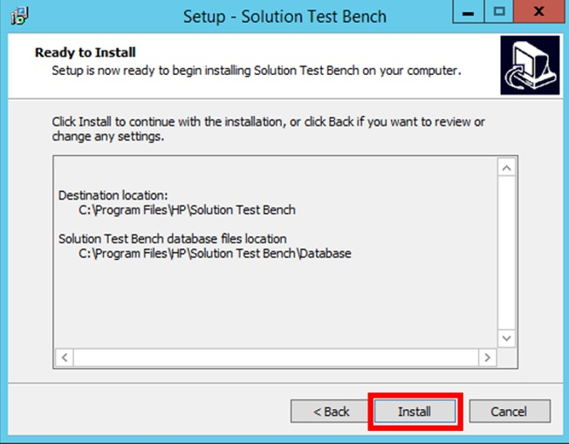

Continue to the next section entitled Database Creation and Version Updates.

## Database Creation and Version Updates

1. Database schema and version updates are applied.

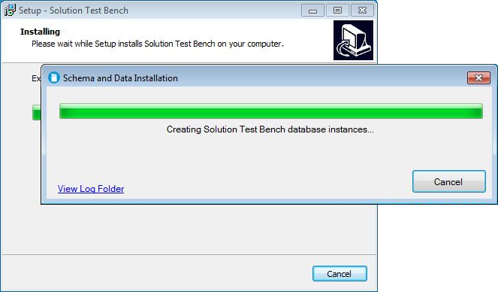

1. Click **Finish** to complete the Solution Test Bench Setup.

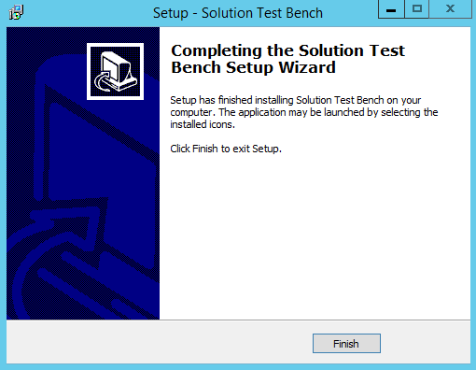

# Updating an Existing STB Server Installation

If an existing version of STB is detected on the target server, the STB Installer will perform only the operations necessary to update the installation to the version indicated by the installer. This is the recommended method for upgrading STB.

For example, if the target server has a current STB version of 4.2.8, and the installer for STB version 4.5.6 is run, then the STB related files will be updated to 4.2.8 as well as the database updates necessary to synchronize the database schema with STB 4.5.6.

1. Right-click the STB Server installation file and select **Run as Administrator** to determine if pop-up warning appears:
   1. If the **Setup** pop-up warning stating that installer must be run with elevated administrator privileges displays, refer to Troubleshooting Guide – Elevating Admin Privileges.  
      
   2. If the **Welcome to Solution Test Setup Wizard** displays, go to the next step.
2. Click **Next** on the Welcome and component installation screens.



1. Accept the default settings for the following screens during installation:

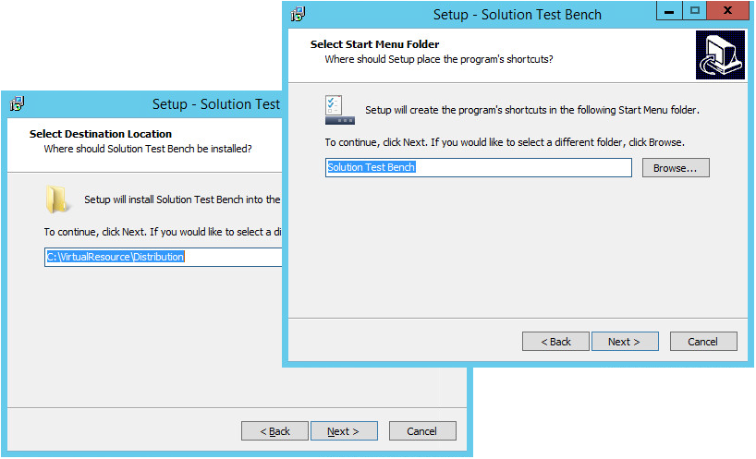

## Troubleshooting a Failed Upgrade

If an STB upgrade installation fails to complete successfully, the recommended procedure is to uninstall the current STB installation before re-running the STB Installer file. The uninstall process will remove all STB related code files, but will leave the following:

* Test reports or history of previous test runs.
* Test Scenarios.
* Definition of any Virtual Workers / Virtual Solutions Testers.
* Any current STB configuration settings, including but not limited to: the Print Device Inventory, Print Server Inventory, Activity Plugin References, Global System Settings, and Virtual Worker Account Pools.

It is not necessary to uninstall SQL Server or remove any of the STB related database files unless the intent is to start completely from scratch. It is recommended that the database installation and files remain intact.

Complete the following steps to uninstall STB:

1. Uninstall previous STB Client version on all clients
   1. Select “HP Solution Test Bench” in Control Panel \ Programs and Features
   2. Click “Uninstall”
   3. Accept all default answers
2. Uninstall previous STB Server version
   1. Select “HP Solution Test Bench” in Control Panel \ Programs and Features
   2. Click “Uninstall”
   3. Accept all default answers
3. Leave SQL Databases as-is
   1. Verify the database and data are still intact. The easiest way to do this is with a utility called sqlcmd. sqlcmd is a command-line utility that can be used to connect with and view data in the STB database. It should already be installed on your Windows machine if you installed STB, but if it is not, you will have to download and install the utility. It can be downloaded from the following URL:

<https://www.microsoft.com/en-us/download/details.aspx?id=53591>

* Start the sqlcmd utility. If your database is intact, the user name and password below will work

sqlcmd -U document_admin -P document_admin

* If connection to the database service was successful, you should see the following prompt:

>1

* This is a good sign. At the current prompt, enter the following command:

use EnterpriseTest <press enter key>

go <enter>

* You should see the following text printed:

Changed database context to 'EnterpriseTest'.

1>

* Enter the following command:

select count(*) ScenarioCount from EnterpriseScenario <enter>

go <enter>

* You should see the following text printed:

ScenarioCount

-------------

2

(1 rows affected)

1>

* Congratulations! You're database is intact. Enter the following command to exit sqlcmd:

exit <enter>

go <enter>

* The 1> in front of your cursor will be replaced by the current directory. Something like:

C:\Users\joe

1. Install new STB Server version pointing to the existing SQL Instance
   1. Run the STB Server executable with the “Run as Administrator” option
   2. If a message window displays about the “C:\VirtualResource” folder already existing, click “Yes” to use the existing folder.
   3. Accept all default answers
   4. Execute the following 2 applications to ensure connectivity to the database and exiting data was retained
      1. “C:\VirtualResource\Distribution\ControlPanel\hpstbcp.exe”
      2. “C:\VirtualResource\Distribution\STBUserConsole\SolutionTestBench.exe”
2. Install new STB Client version on clients
   1. Run the STB Client executable
   2. Enter the appropriate STB Server Address
   3. If a message window displays about the “C:\VirtualResource” folder already existing, click “Yes” to use the existing folder.
   4. Accept all default answers
   5. Open the STB User Console “C:\VirtualResource\Distribution\STBUserConsole\SolutionTestBench.exe”
   6. Verify connection to the STB server
3. Test the installation by opening STB and ensuring the existing data is still displayed. Create a small test and run it as a final test.

## Plugin Changes

Plugins assemblies are compiled to work with a particular version of STB. If the STB interface changes between an existing version and a new version, the old plugin versions may not work (i.e. they will cause an exception when you browse to configure the plugin settings within the User Console.)

There is a base set of plugins that are included in each STB release. These will be automatically updated and are compatible with the new version of STB being installed.

If you are using other plugins obtained from HP that are NOT part of the set of standard plugins released with STB (i.e. you received them separate from the STB install package as .dlls) then you may need to request updated plugins to work with the newer STB version.

If you have developed and coded your own plugins, you may need to recompile the assemblies. Simply update the “STF.Framework.dll” by replacing the existing version with the new one provided in the new STB version, and then remove and re-add the reference in Visual Studio, recompile your plugin assembly, and recopy the .dll to your Plugin folder (as described in the Plugin Developers Guide.)

# Administrator Server Configuration Overview

Once setup is complete, the following actions will need to be performed by the administrator to allow the STB User Console to be downloaded and enable Test Scenario creation:

1. Create Users Groups (a minimum of 1) to categorize users and provide security access options to the test scenarios.
2. Add Authorized Users – these are the managers, engineers and testers that can access STB to create or execute test scenarios, or view the results and reports stored in STB.
3. Schedule database cleanup if desired.

In addition, the Administrator can add resources needed to enable Test Scenario creation:

1. Add devices to the STB inventory, either standalone print devices or print servers.
2. Add test documents to the Test Document Library.
3. Create a Virtual Worker Pool to execute scenario workflows.

Instructions for all Administrator tasks can be found below. Specific set-up instructions for Test Scenarios are available in the **STB User Guide**.

## Access STB Admin Control Panel

To access the **Admin Control Panel**, follow these steps:

1. Locate the **Solution Test Bench** folder from the Start Menu.
2. Click the **Admin Control Panel** to open the **Solution Test Bench Control Panel**.

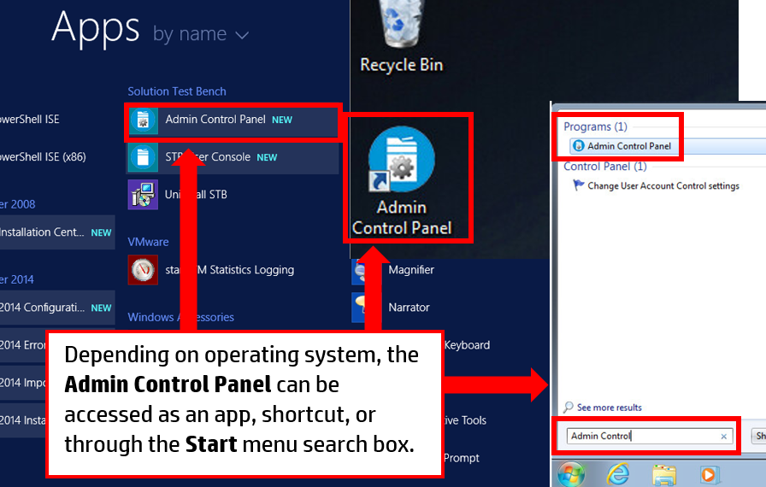

1. Select the link in Fig 3.0 below that matches the action you would like to take:
   1. **STB User Groups** – select for User Group Management. Options include adding new user groups, editing or removing existing user groups, and editing user group membership.
   2. **STB Authorized Users** – select for Authorized User Management. Options include adding individual authorized users, and editing or removing authorized users.
      1. **Note:** User access to scenarios is edited in the User Console.
   3. **Print Device Inventory** – select for STB Device Management of standalone print devices, including adding a new print device, or editing or removing existing print devices.
   4. **Print Server Inventory** – select for STB Device Management of entire print servers, including adding new print servers, editing print servers, or removing print servers.
   5. **Test Document Library** – select to access the Test Document Library where new test documents can be added, or existing test documents can be edited or removed.
   6. **Virtual Worker Pool** – select to access the Virtual Worker Pool, allowing the admin to add new virtual worker pools, or edit and remove existing virtual worker pools.
   7. **Scheduling Cleanup of Database** – select to schedule routine database cleanup.

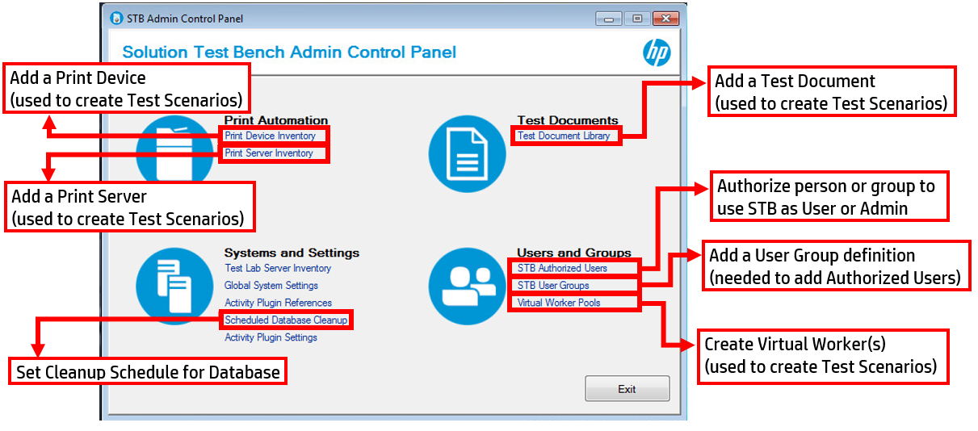

# STB User Management

## User Group Management

You can create administrator defined categories for your added users. This not only manages the list of authorized users for the STB, but also determines who has editing rights for the scenarios created. Typically, any user group associated with a scenario will have edit rights.

Users can be grouped by team, function, geography, or any other category needed. A user can be a member of multiple groups, but you must define at least a single group for users to be a part of.

This section contains instructions for the following actions:

* Adding New User Groups
* Editing or Removing a User Group
* Editing Membership of a User Group

### Adding New User Groups

To create a group, follow these steps:

1. Access the Admin control panel and select the **STB User Groups** link to open the **UserGroup Management** window.
2. Click **Add** to open a new **User Management** window.
3. Type an appropriate **Group Name**.
4. Type a **Description**.
5. Click **OK** to create the new Group and populate the **UserGroup Management** window.
6. Click **OK** to save the changes and exit to the Admin control Panel.   
     
   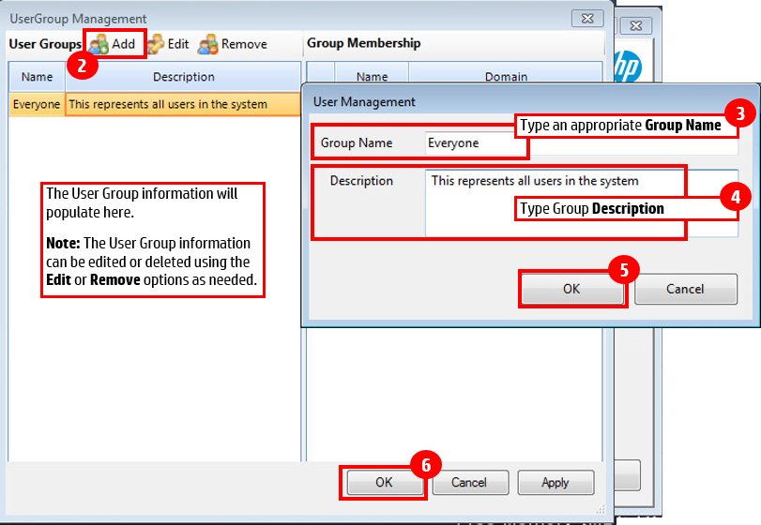

### Editing or Removing a User Group

To edit the description or Group Name:

1. Access the Admin control panel and select the **STB User Groups** link to open the **UserGroup Management** window.
2. Select the User Group to edit in the left pane.
3. Click **Edit** to open a new User Management window.
   1. **Note:** If removing a group simply click **Remove**, then go to Step 6.
4. Update the **UserGroup Management** window as needed.
5. Click **OK**.
6. Click **OK** to save the changes and exit to the Admin control Panel.   
     
   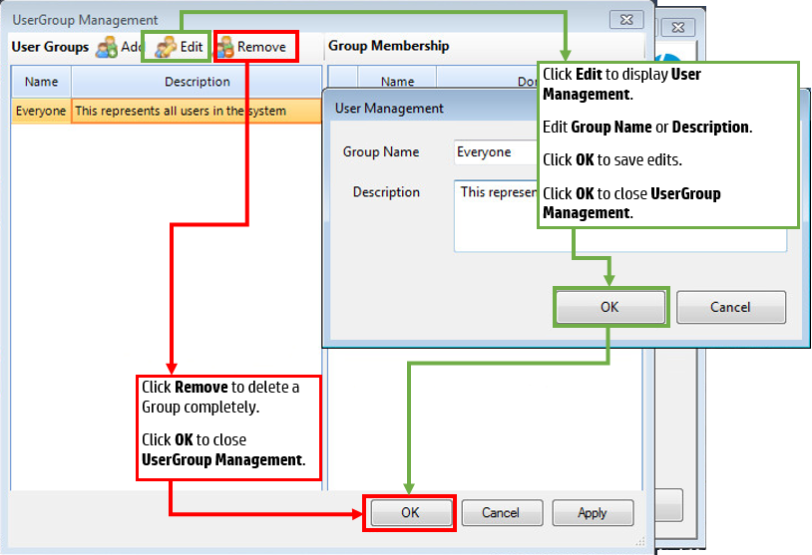

### Editing Membership of a User Group

To add or delete authorized users in the group:

1. Access the Admin control panel and select the **STB User Groups** link to open the **UserGroup Management** window.
2. Select the User Group to edit in the left pane.
3. Check the box next to an authorized user to add them to the group, uncheck the box to remove an authorized user.
4. Click **OK** to apply the changes.   
     
   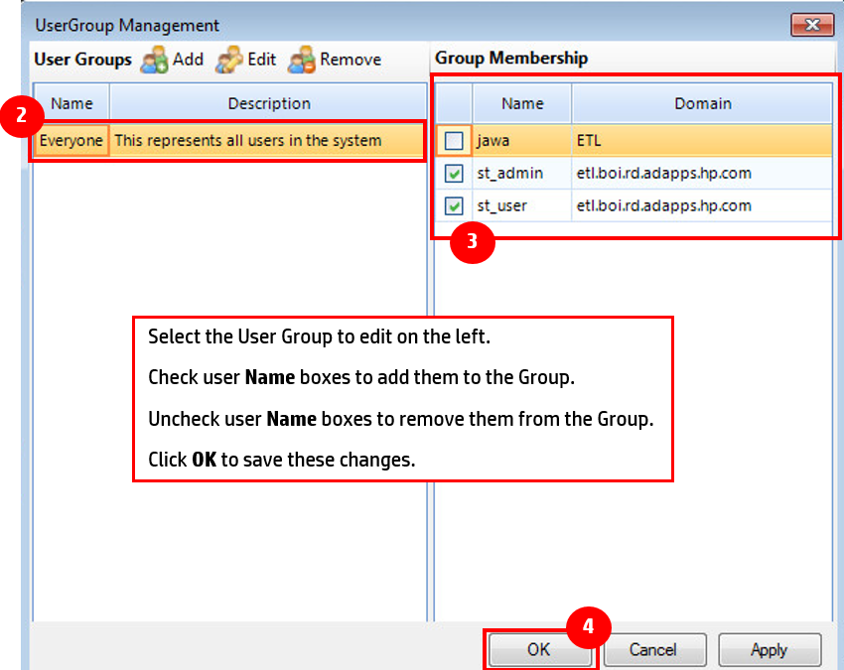

## Authorized User Management

Adding authorized users allows the administrator to set permissions for testers, engineers or managers to create or execute Test Scenarios. Permissions granted are based on User Groups and Roles assigned here.

This section contains instructions for the following actions:

* Adding Authorized Users
* Editing and Removing Authorized Users

### Adding Authorized Users

Complete the following steps to add Authorized Users:

1. Access the Admin control panel and select the **STB Authorized Users** link to open the **User Management** window.
2. Click **Add** to bring up **User Management**.
3. Complete the **User Management** fields:
4. Type the **User** **Name** and **Domain**.
   * **Warning:** Once a User Name is created, it will not be editable.
5. Select the appropriate **User Role** from the drop-down:
   * **Guest** – the default role. Guests can view information, but cannot execute tests or edit Scenarios. Users accessing the Console who have not been added as authorized users will automatically be guests.
   * **User** – the general user. Users can execute tests and create scenarios. They can edit scenarios they own or scenarios owned by the User Group(s) they are members of.
   * **Manager** – expanded user role. Managers can execute tests, create scenarios, and edit any scenario saved in the system.
   * **Administrator** – the administrator role has access to all features of the STB.
6. Check each **User** **Group** the user should be a member of.
7. Click **OK**.
8. Click **Apply** and **OK** to close **User Management**.

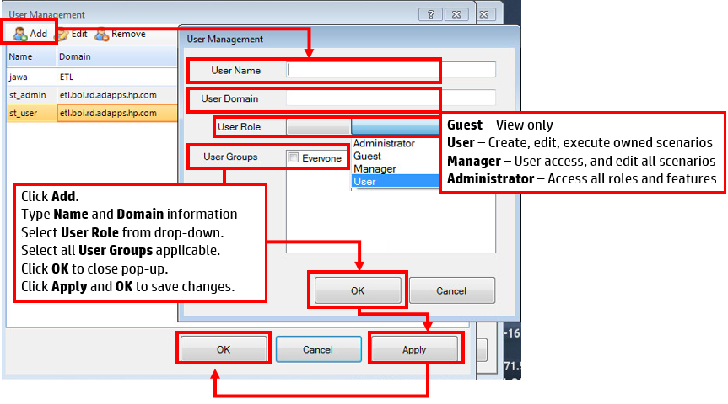

### Editing and Removing Authorized Users

Complete the following steps to add Authorized Users:

1. Access the Admin control panel and select the **STB Authorized Users** link to open the **User Management** window.
2. Select the User Name to edit in the left pane.
3. Click **Edit** to open a new User Management window.
   1. **Note:** If removing a group simply click **Remove**, then go to Step 6.
4. Update the **UserGroup Management** window as needed.
5. Click **OK**.
6. Click **Apply** and **OK** to save the changes and exit to the Admin control Panel.  
     
   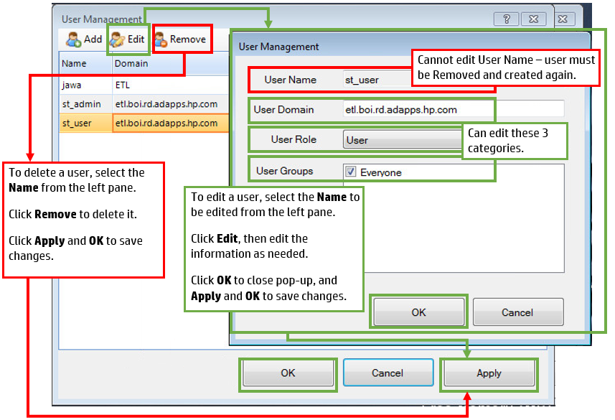

## Editing Group Scenario Access and Ownership

Once scenarios are created, access and ownership to these groups can be edited by the administrator in the STB User Console.

**Note:** If STB User Console is not installed, refer to the **STB User Guide** for installation instructions.

1. Search for the **STB User Console** or click the desktop icon to open it.
2. Select **Test Configuration** tab and the scenario to edit from the scenario list.
3. To edit Authorized Group edit and executions rights:  
   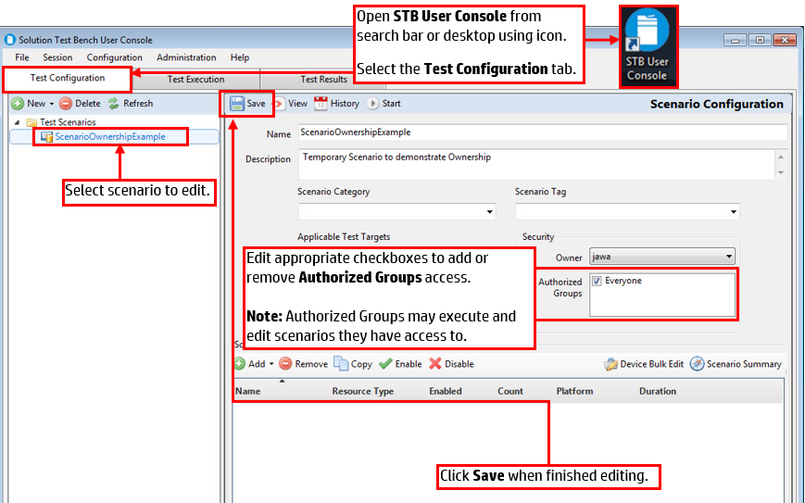
4. To edit scenario Owner:  
   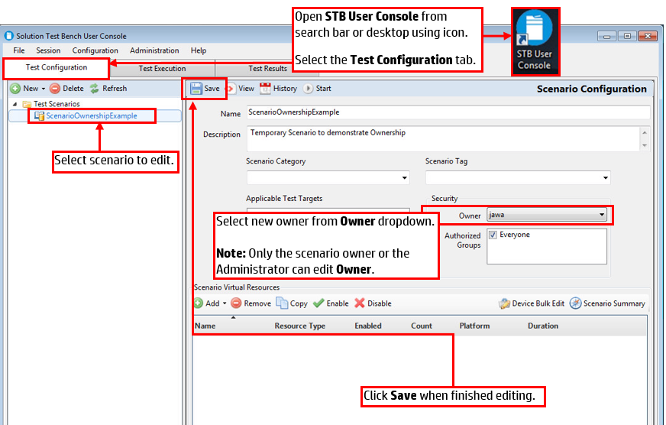

# STB Device Management

STB Test Scenarios execute against print devices. STB can utilize with either standalone print devices or print devices accessed through a print server.

To manage standalone print devices to STB, select instructions for the following actions:

* Adding Print Devices
* Editing and Removing Print Devices

To manage print servers, select instructions for the following actions:

* Adding Print Servers
* Edit or Review Print Servers
* Remove Print Servers

## Adding Print Devices

To add devices to the STB Server, complete the following steps:

1. Access the Admin control panel and select the **Print Device Inventory** link to open the **Print Device Inventory** window.
2. Click **Add** to open the **Add Printer** pop-up.
3. Type the **IP** **Address** and **Device Password** of the device to be added.
4. Click **OK** to connect to the device and bring up the **Print Device Properties** window.

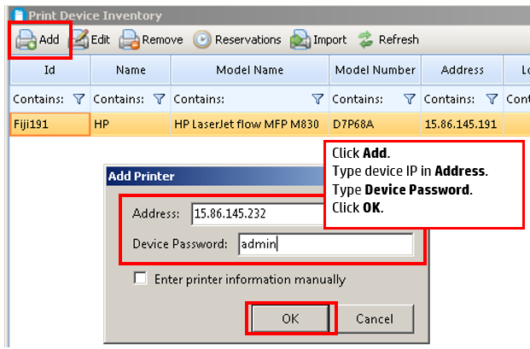

1. Type a device name in the Printer Name field.
2. Click **OK** to add the device to the Print Device Inventory.
3. Click **Apply** and **OK** to save changes when you are done adding devices.  
   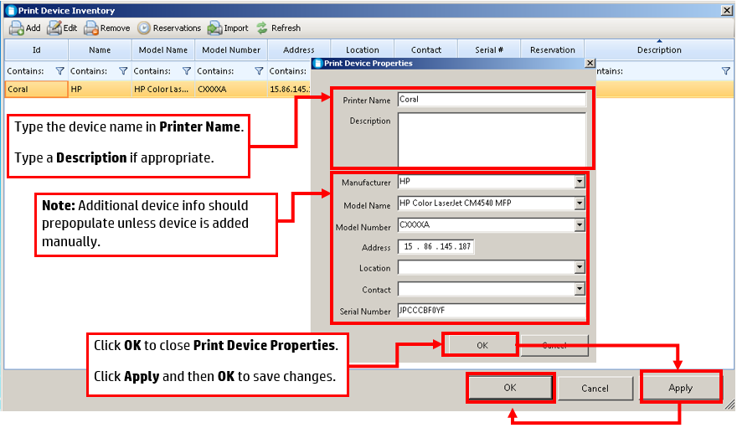

## Editing and Removing Print Devices

1. Access the Admin control panel and select the **Print Device Inventory** link to open the **Print Device Inventory** window.
2. Select the **ID** to edit in the left pane.
3. Click **Edit** to open a new **Print Device Properties** window.
   1. **Note:** If removing a group simply click **Remove**, then go to Step 6.
4. Update the **Print Device Properties** window as needed.
5. Click **OK**.
6. Click **Apply** and **OK** to save the changes and exit to the Admin control Panel.  
   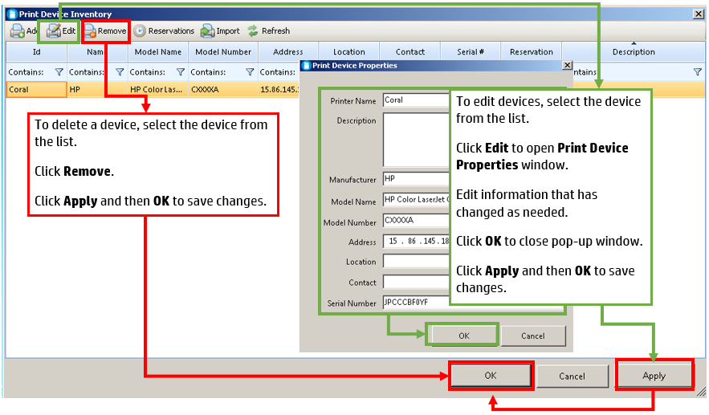

## Adding Print Servers

1. Access the Admin control panel and select the **Print Server Inventory** link to open the **Print Server Management** window.
2. Click Add to open the Add Server pop-up.
3. Type the **Server Hostname**.
4. Click **OK** to open the **STB Server Properties** window.   
     
   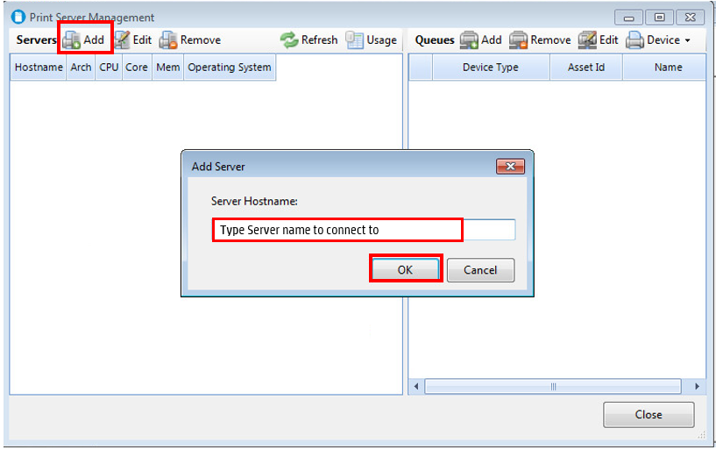
5. Select all Server Attributes that apply to the print server being added:
   1. **File Server** – Server used by DSS and other file based systems
   2. **Print** – General print server used in UPD testing, etc.
   3. **Production** – Production system, used for production level testing
   4. **Solution** – Solution applications server (3rd party)
6. Click **OK** to add the Server.  
   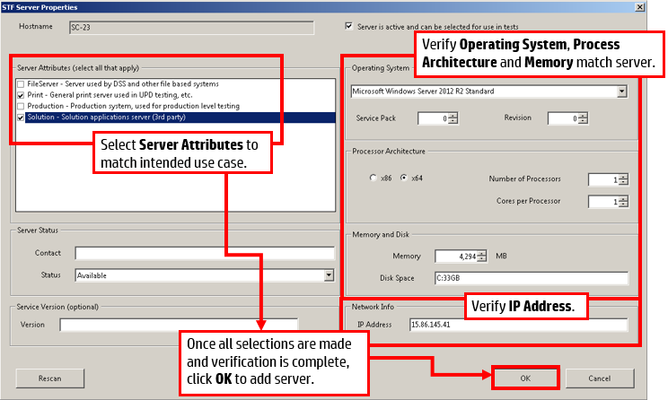
7. A Print Queues Refreshed box will appear when the server is added.
8. Click **OK.**
9. Click **Close** to exit the **Print Server Management** window.   
      
   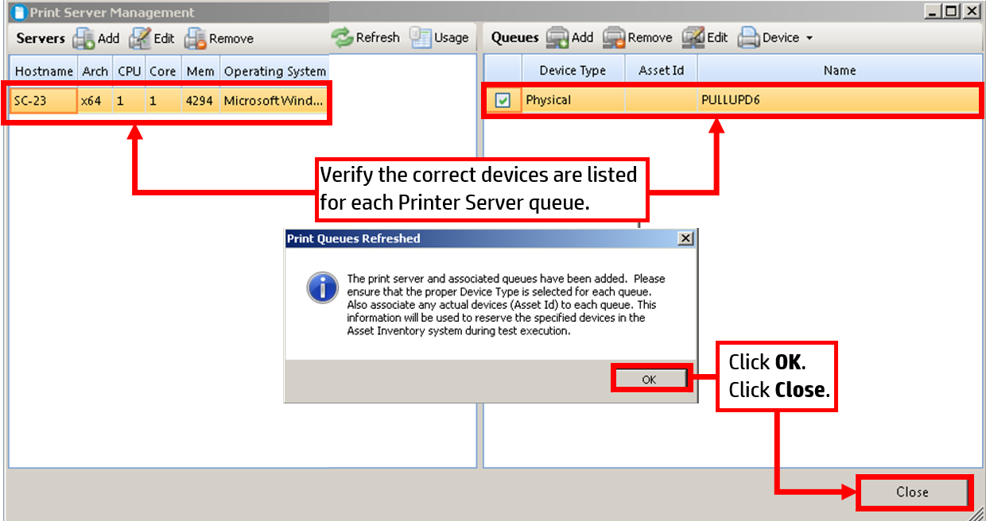

## Edit or Review Print Servers

To review or refresh server and queue information:

1. Access the Admin control panel and select the **Print Server Inventory** link to open the **Print Server Management** window.
2. Select the server you wish to update.
3. To refresh the printer queue, click **Refresh**.   
     
   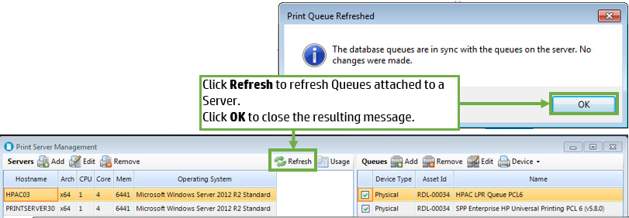
4. Determine what scenarios the print server is currently supporting. Refer to Determine Print Server Device Allocation.
5. To edit the print server click **Edit** and update as needed.
6. Click **OK** once needed settings are updated.   
     
   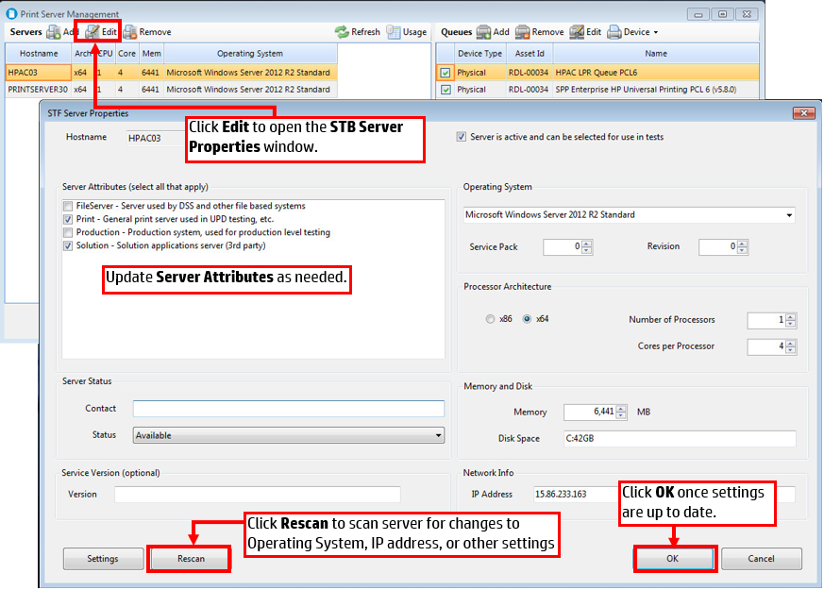

## Remove Print Servers

To remove either a print server or specific device from the inventory, follow the steps below:

1. Access the Admin control panel and select the **Print Server Inventory** link to open the **Print Server Management** window.
2. Determine what scenarios the print server is currently supporting. Refer to Determine Print Server Device Allocation.
3. If active scenarios will not be disrupted, select server to delete and click **Remove**.
4. Click **OK** to accept deletion.
5. Click **Close** to close the window.  
     
   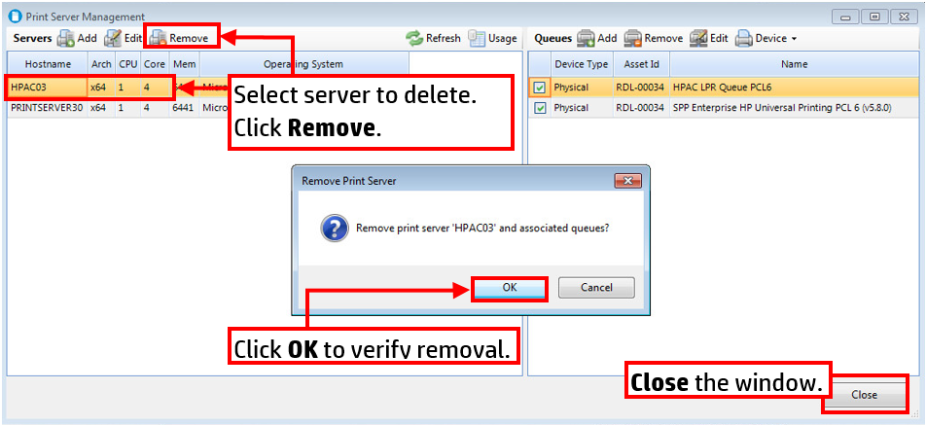

# Test Document Library

Test documents are used while executing scenarios to perform certain tests, and all documents used are stored on the server in the Test Document Library. Both the administrator and the general user are able to add, edit, or remove documents from the Test Document Library.

This section contains instructions for the following actions:

* Adding test documents to the Test Document Library
* Editing or removing documents in the Test Document Library

## Add Test Documents to Library

To add a document to the Test Document Library, follow the steps below:

1. Access the Admin control panel and select the **Test Document Library** link to open the **Test Document Library** window.
2. Click **Add** to open the browsing window.
3. Select the file you wish to add from your available files.
4. Click **Open** to the **Test Document Properties** window.  
     
   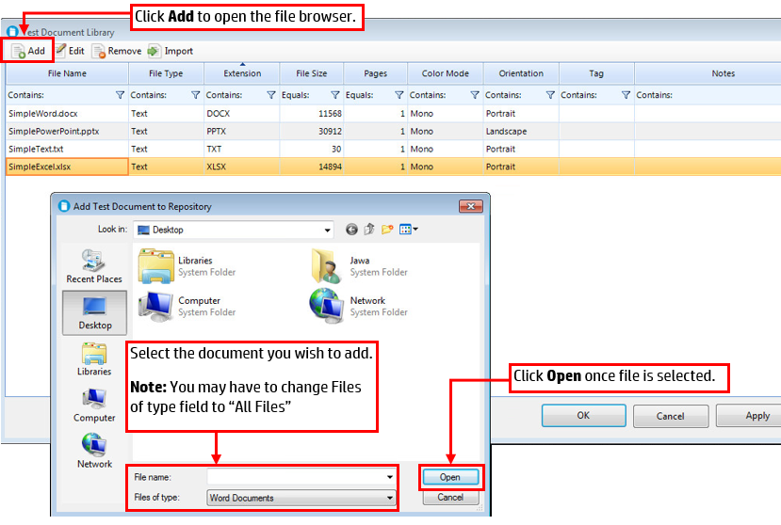
5. Update the Text Document Properties fields:
   1. Verify **File Type** matches file selected.
   2. Select type of **Color Mode** document should use.
   3. Select **Orientation** of document.
   4. Select **App Name** to be used to open document if applicable.
      1. **Warning:** Any document using a specific app can only be executed on machines with that app installed. (E.g., if the scenario requires Microsoft Office, the user must have Microsoft Office available.
   5. Type a description or comments in **Notes** if necessary.  
        
      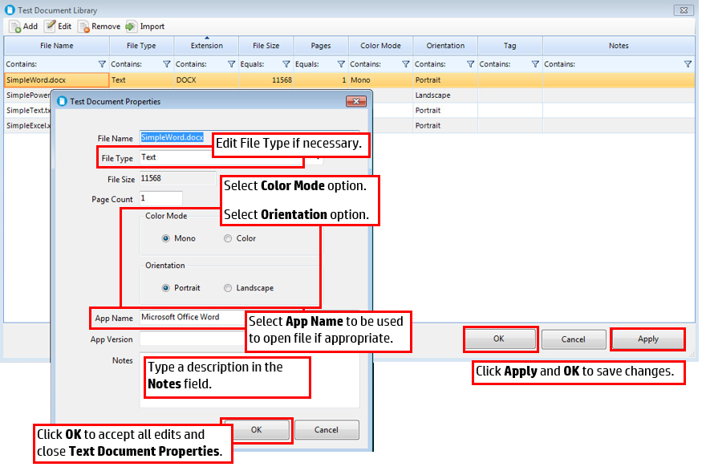  
      *Fig 6.2 – Adding Document Details*
6. Click **OK** to save updates.
7. Click **Apply** and **OK** to save changes. Document will now appear in Test Document Library.

## Edit or Remove Documents in Document Library

To edit or remove a document to the Test Document Library, follow the steps below:

1. Access the Admin control panel and select the **Test Document Library** link to open the **Test Document Library** window.
2. Select document to be edited.
3. Follow the instructions below to **Edit** or **Remove** the document as needed:  
     
   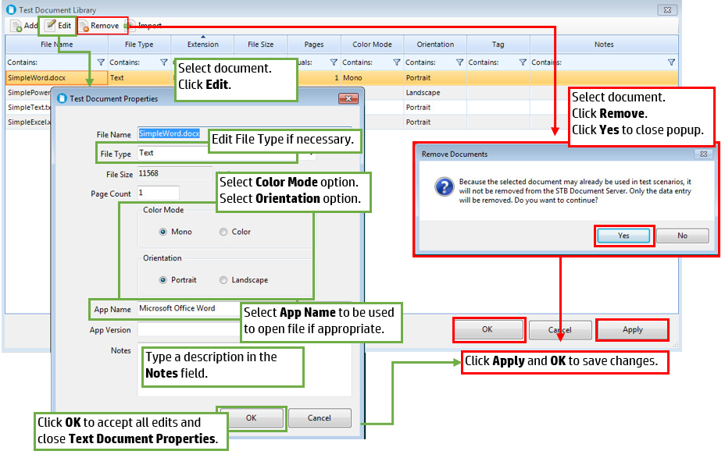

# Virtual Worker Pool

Virtual Workers are the automated programs that simulate an office worker doing a preassigned task during a Scenario. The workers are grouped in pools, which are assigned in whole or in part to the scenarios. As an administrator you create or setup Virtual Worker Pools.

This section contains instructions for the following actions:

* Adding Virtual Worker Pools
* Editing or Removing Virtual Worker Pools

## Adding Virtual Worker Pools

To add a new virtual worker pool, follow the steps below:

1. Access the Admin control panel and select the **Virtual Worker Pools** link to open the **Virtual Worker Account Pools** window.
2. Click **Add** to open the Virtual Worker Account Pool window.
3. Type a **Pool Name** for the new pool of Virtual Workers.
4. Type the format for the Virtual Workers.
   1. Available Username Formats include:
      1. **u{0:00000}** (e.g., u00001, u00025, u99999)
      2. **{0:00000}** (e.g.,00001, 00025, 99999)
      3. **prefix{0:000}suffix** (e.g., prefix001suffix, prefix025suffix, prefix999suffix)
      4. **{0:00}suffix** (e.g., 01suffix, 25suffix, 99suffix)
5. Type **Start Index** number if applicable. (The default is 1.)
6. Type End Index number if applicable. (The default is 99.)
7. Type a **Description** for the Virtual Worker Pool if needed.
8. Click **OK** to close the Virtual Account Pool pop-up window.
9. Click **Apply** and **OK** to save changes.  
     
   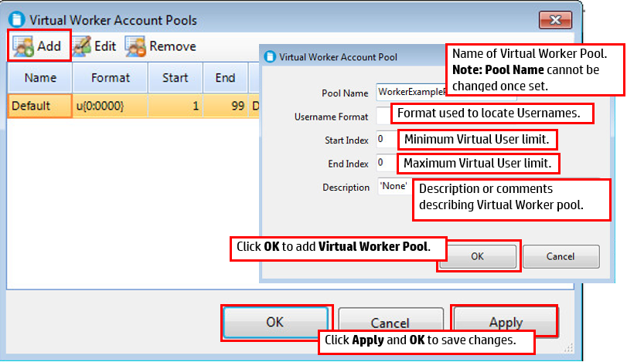

## Edit or Remove a Virtual Worker Pool

To edit or delete an existing virtual worker pool, follow the steps below:

1. Access the Admin control panel and select the **Virtual Worker Pools** link to open the **Virtual Worker Account Pools** window.
2. Select the Virtual Worker Pool to be updated.
3. Edit or Remove the Virtual Worker Pool following the instructions below:  
     
   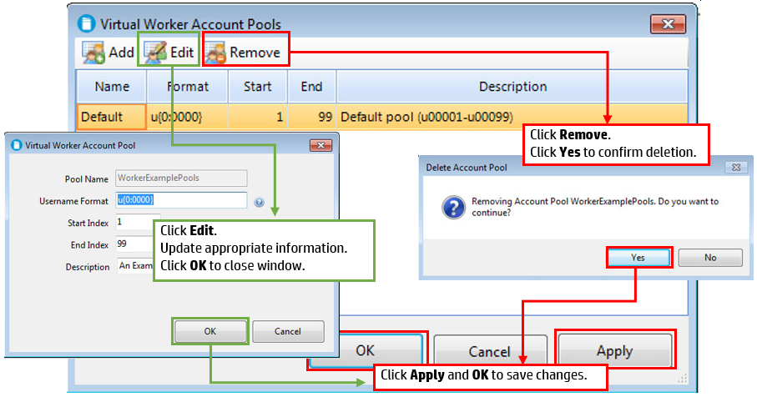

Virtual Worker account pools are groups of domain users that will be used by STB to run the tests. When STB starts a test, it starts processes on the client machine that run as domain users. For example, you could set up a group of users on your domain with the following user names:

u00001

u00002

u00003

u00004

You would then fill out the form above with the following information:

User Format: u{00000}

Start Index: 1

End Index: 4

Description: STB Test Users

# Scheduling Cleanup of the Database

It is recommended that a periodic cleanup of the STB database is performed, to remove runtime and results data that has exceeded the selected retention period. The administrator can set the frequency and schedule of this cleanup from the STB Admin Control Panel. These settings may be edited at any time.

To schedule cleanup, follow the steps below:

1. Access the Admin control panel and select the **Scheduled Database Cleanup** link to open the **Scheduled Database Cleanup** window.
2. Verify the **Cleanup Job Enabled** option is checked.
3. Select **Cleanup Schedule**. (Daily is recommended.)
4. Select the initial Start date and time using the date picker and clock fields.
5. Select a maximum cleanup runtime from the **Stop cleanup job…** drop-down menu.
6. Click **OK** to save settings.   
     
   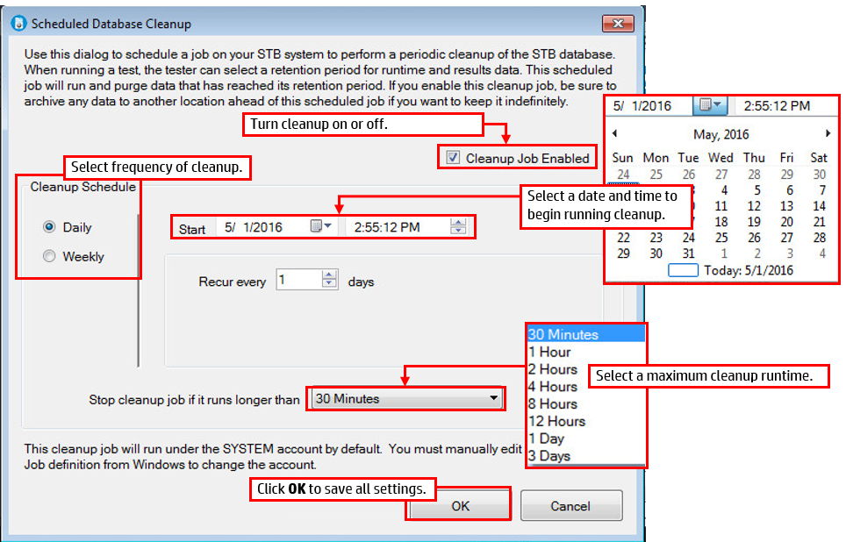

# Troubleshooting Guide

## Update Domain Controller Relationship

To unjoin and rejoin the domain, follow the steps below:

1. Click the **Start** button.
2. Right-click **This PC** or **Computer** depending on Windows version.
3. Select **Properties** to open the **System** window.  
   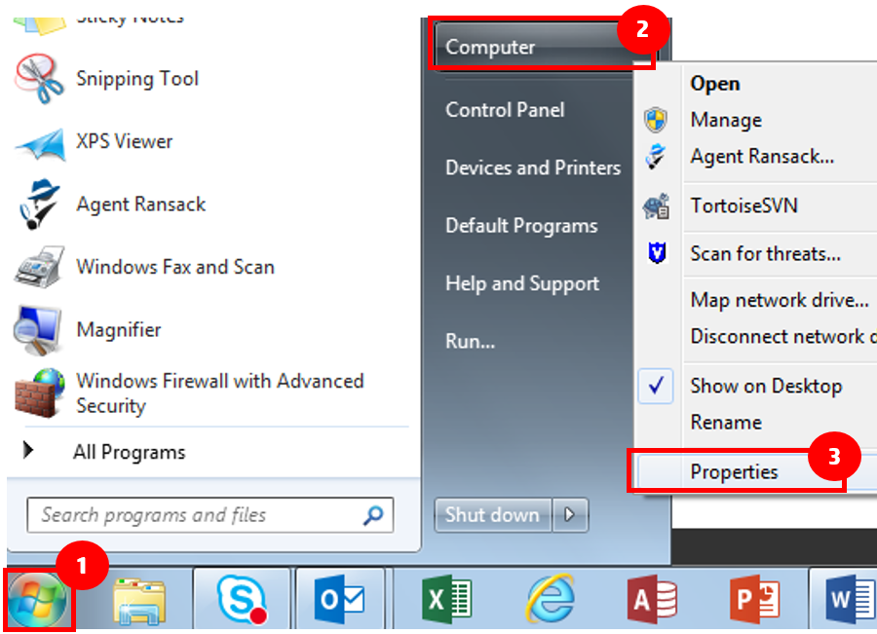
4. Note the domain.
5. Click **Change Settings** to open the **System Properties** window.
6. Verify the **Computer Name** tab is selected.
7. Click **Change** to open the **Computer Name/Domain Changes** window.  
     
   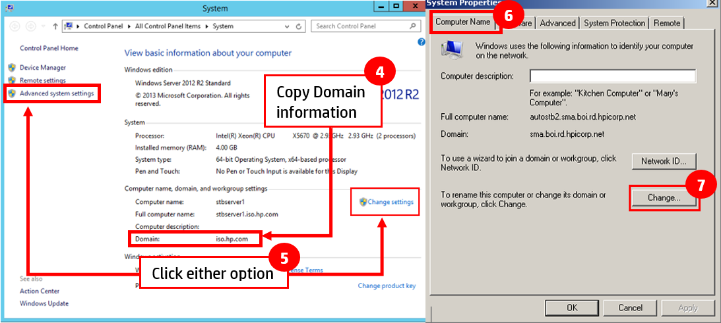
8. Select **Workgroup** and create a name.
9. Click **OK** to display a domain log in warning.
10. Click **OK** to continue past the warning.  
    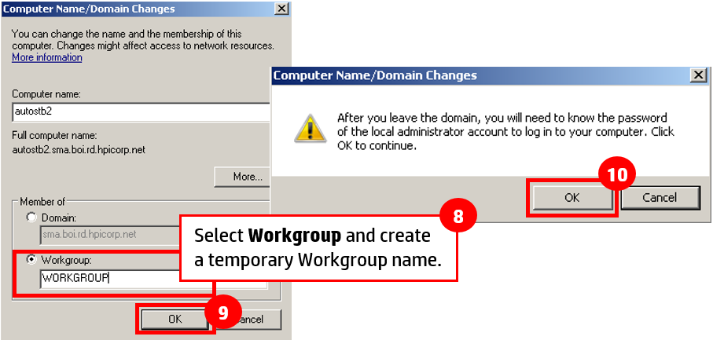
11. When prompted, click **Restart Now** to reboot the server and unjoin the domain.
12. Log back in as the local administrator.
13. Repeat Steps 1-7 of this troubleshooting guide to open the **Computer Name/Domain Changes** window again.
14. Select Domain and type in the domain name noted in Step 4.
15. Click **OK** to display a domain log in warning.
16. Click **OK** to continue past the warning.  
    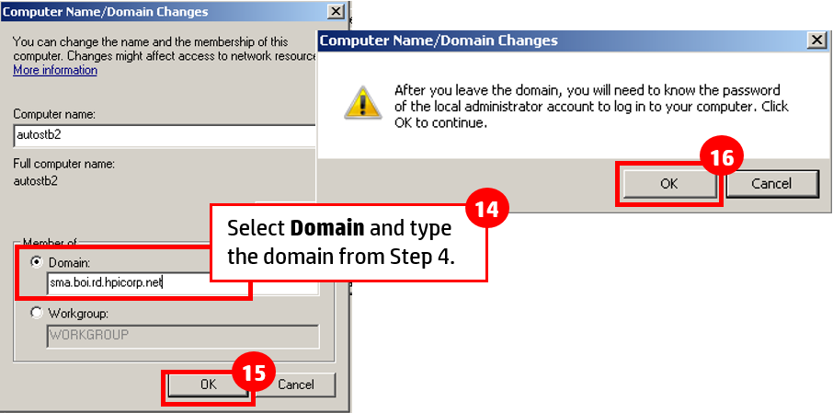
17. When prompted, click **Restart Now** to reboot the server and unjoin the domain.
18. Log back in as the local administrator.
19. Verify the domain controller relationship.

## Elevating the Admin Privileges

If you are logged into your machine as the built-in administrator account while installing Solution Test Bench, you may experience an error message, even when you have selected “Run as administrator”. Using the built-in administrator account is not recommended when using Solution Test Bench. The recommended solution for this problem is to log out of the built-in user account and re-login as a different local administrator. Doing so should allow you to continue installation of Solution Test Bench without the error regarding elevated admin privileges. However, if the built-in administrator account must be used, please follow the directions below to allow the Solution Test Bench installer to be run.

1. Close the STB setup window.
2. Click the **Start** button.
3. Type **gpedit.msc** in the search field.
4. Select **gpedit** to open the **Local Group Policy Editor** window.  
   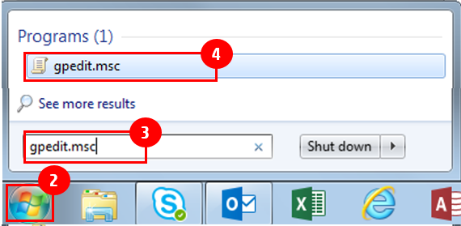
5. Expand the following folders to display all folders within them:
   1. **Computer Configuration**.
   2. **Windows Settings**.
   3. **Security Settings***.*
   4. **Local Policies**.
6. Click **Security Options**.
7. Select **User Account Control: Admin Approval Mode for the Built-in Administrator account** to display the **User Account Control** pop-up.  
     
   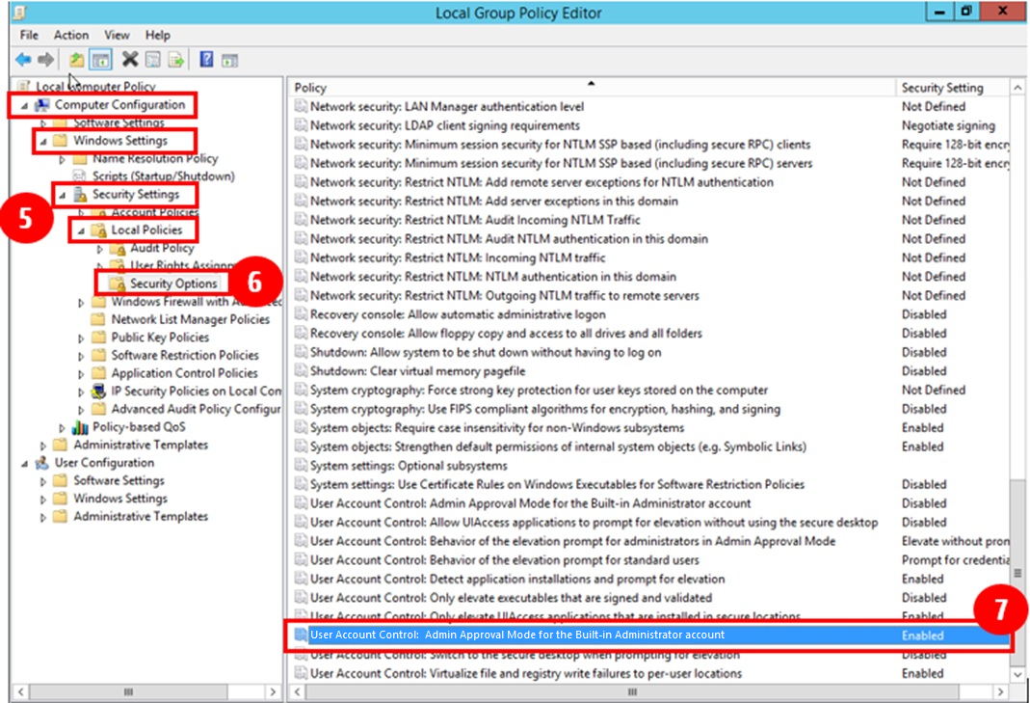
8. Change the Local Security Setting to **Enabled**.
9. Click **Apply**.
10. Click **OK**.  
      
    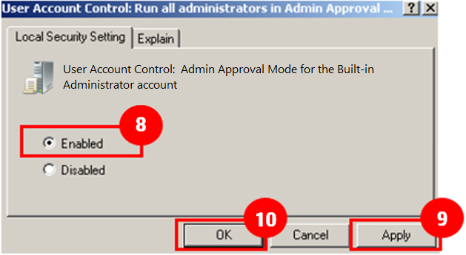
11. When prompted, restart the server.
12. Log in to the server as the local administrator.
13. Right-click the STB server installation file and select **Run as administrator** to display the Welcome to Solution Test Setup Wizard.
14. Return to **STB Server Installation Step 2**.

## Determine Print Server Device Allocation

Determine which scenarios are using which servers and devices to avoid causing conflicts or removing resources being used by other groups.

Follow the steps below to check the print server or specific devices on the server:

1. Access the Admin control panel and select the **Print Server Inventory** link to open the **Print Server Management** window.
2. Determine what scenarios the print server is currently supporting.
   1. Select a server and click **Usage** to review details.  
        
      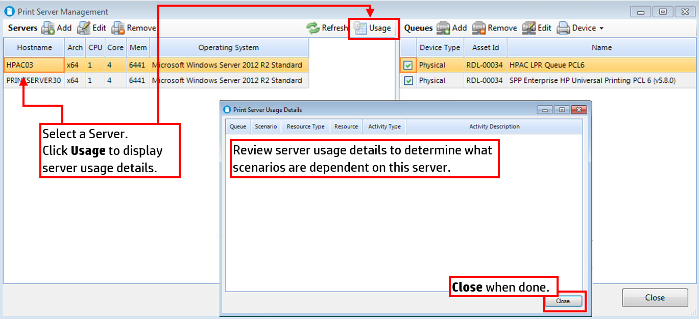
3. To determine details of the specific scenarios the server devices are supporting, go to the **Asset Usages** page:
   1. Click **Device Usage Summary** to view test scenarios affected:  
        
      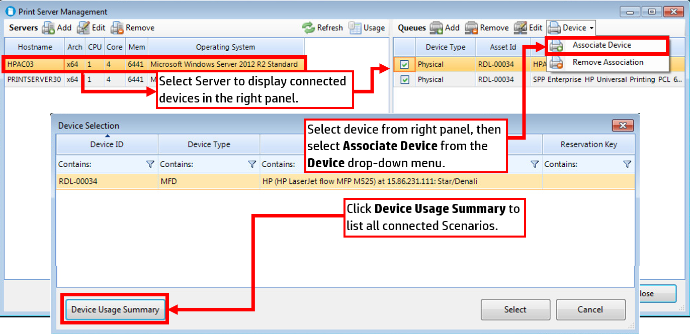
   2. Review the Test Scenarios listed to determine impact.  
        
      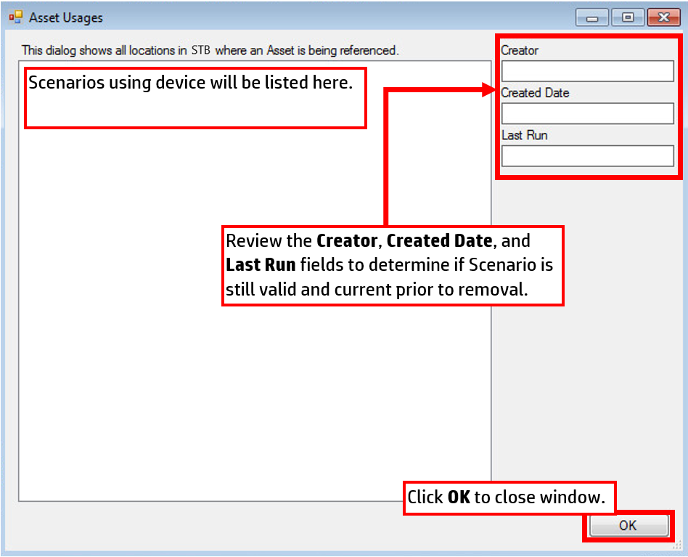
4. Once impact is determined, take appropriate action:
   1. If removing server, return to **Remove Print Servers Step 3**.
   2. If reviewing server, return to **Edit Print Servers Step 5**.

## Connecting to an Existing Database

If the connection to the existing database fails during STB Server installation, check the following:

1. Check if TCP/IP remote connections are enabled.

a. Click on the Windows **Start** button.

b. Find **Microsoft SQL Server 2014** menu item and click it to drop down it’s contents.

c. Find **Configuration Tools** folder and click it to display it’s contents.

d. Click on **SQL Server 2014 Configuration Manager**.

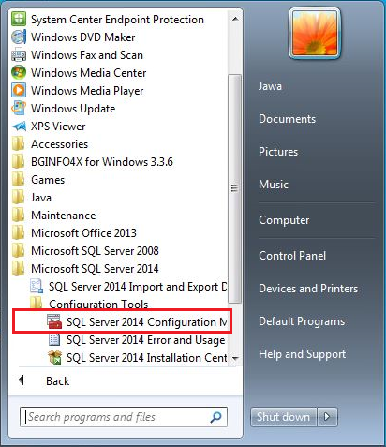

e. Click on **SQL Server Network Configuration** to display it’s contents.

f. Click on **Protocols for SQLEXPRESS**. If you are running a professional version of SQL Server, this may display something other than is shown below.

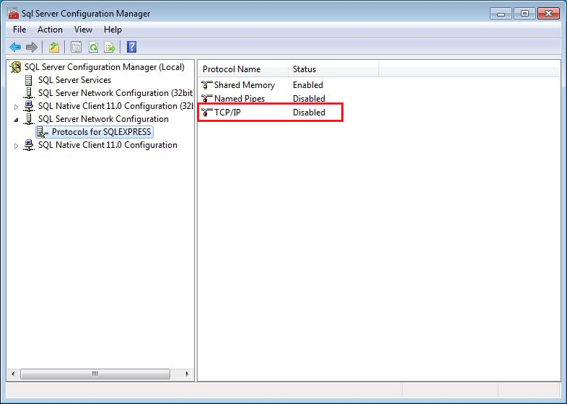

g. In the right-hand pane, note that the value of **TCP/IP** is disabled. Right-click on the value and select **Enabled**.

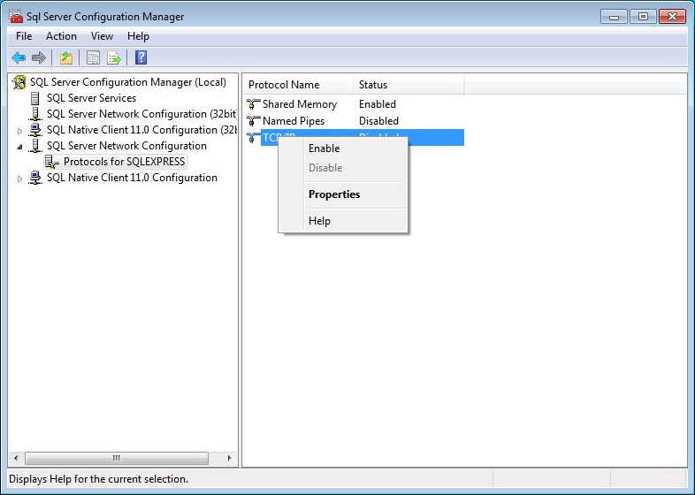

h. After the value is changed, a message will be displayed. Close the message. The service can be restarted after the ports have been verified.

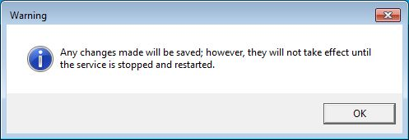

i. After enabling the TCP/IP protocol, right-click on it again and select **Properties**.



j. Under the heading **IP1**, check the value of **TCP Port** and make sure it is set to 1433.

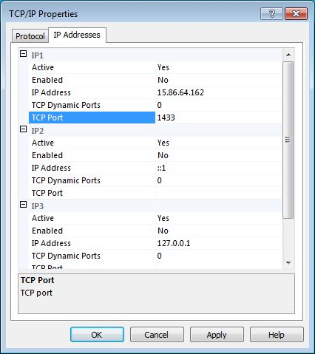

k. Under the heading **IP All**, check the value of **TCP Port** and make sure it is set to 1433.

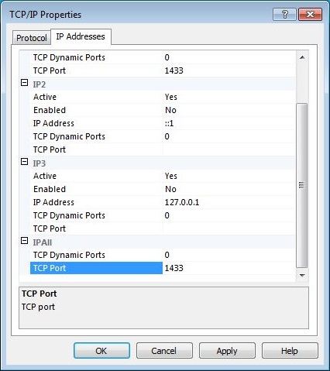

l. After any value is changed, a message will be displayed. Close the message as well as the SQL Server Configuration Manager and continue with restarting the service.



2. Restart the SQL Server Service.

a. Click on the Windows **Start** button.

b. Find and click on **Control Panel**. Click on **Administrative Tools**.

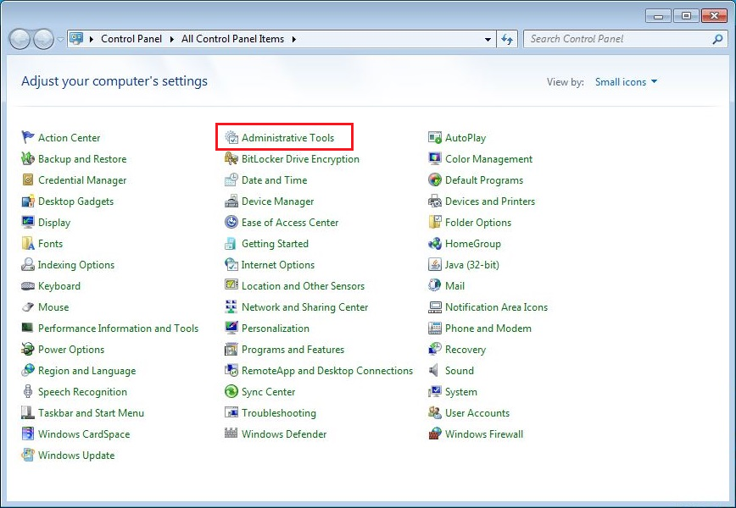

c. Click on **Services**.

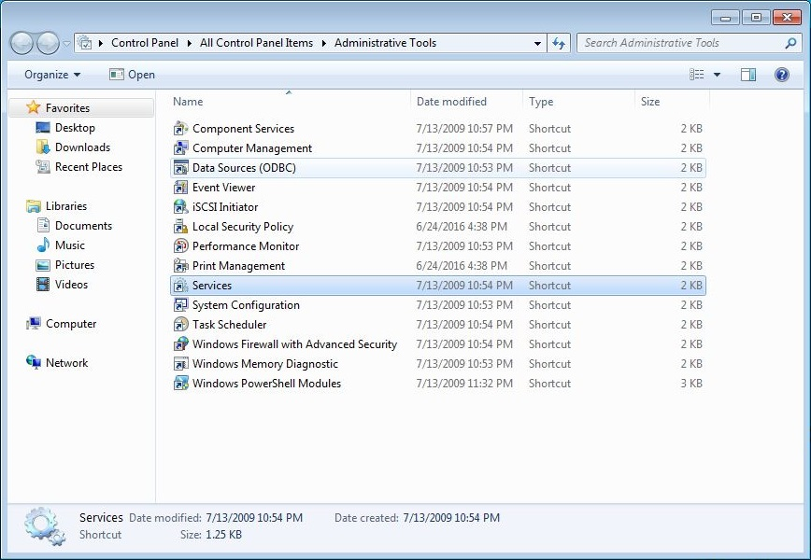

d. Find and select **SQL Server**, then click **Restart the service** in the left column.

